Lab Exam 1 (Set C)

Roll Number :2403A51017

Name=Mohammed Rizwaan Ahmed

Problem 1:

(2 Marks) Write a Python program to extract all URLs (web links) from a block of text using regular expressions. Use the Cursor AI tool with zero-shot prompting to generate the solution

Prompt: Write a Python function that extracts all URLs from a block of text./ The function should detect links starting with http://, https://, or www. and return them as a list.

Code: 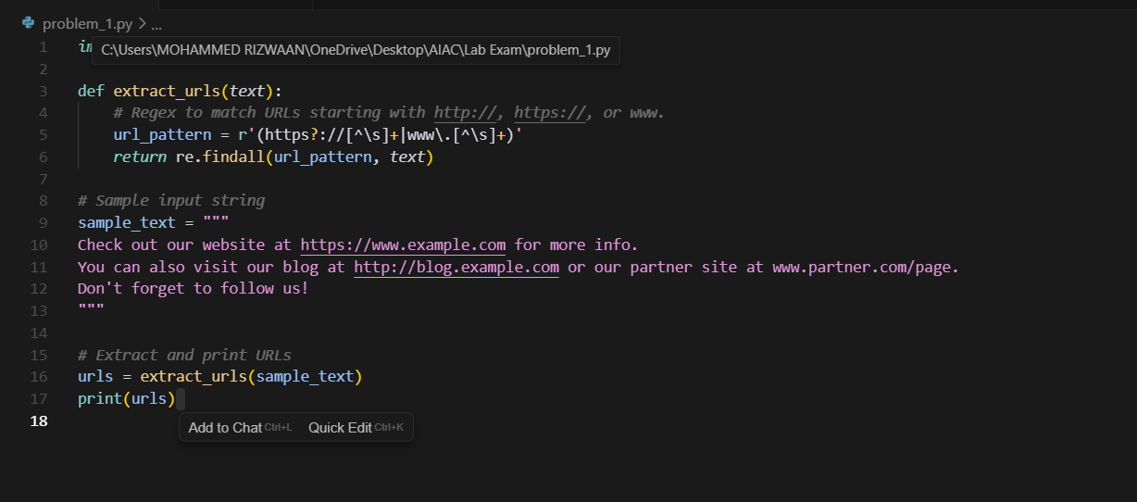

Output:

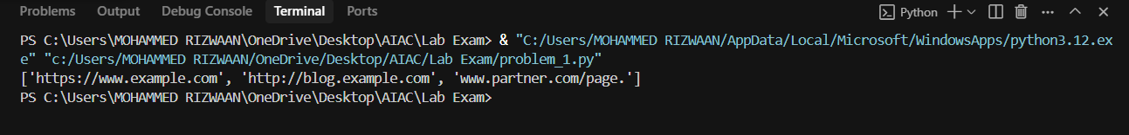

Problem 2:

(2 Marks) Given a list of books with their genres, write a Python function that recommends books based on a user’s preferred genre. Use the Cursor AI tool. Use few shot prompting.

Prompt:

write a Python function that recommends

books based on a user’s preferred genre from the Given a list of books with their genres

example:

{"name": "fragrant flowers", "genre": "romance"},

{"name": "anabelle", "genre": "Horror"},

{"name": "avengers", "genre": "scifi"},

{"name": "pride and prejudice", "genre": "romance"},

{"name": "dracula", "genre": "Horror"},

{"name": "dune", "genre": "scifi"}

1.input:

romance

output:

fragrant flowers

2.input:

Horror

output:

ananbelle

CODE:  
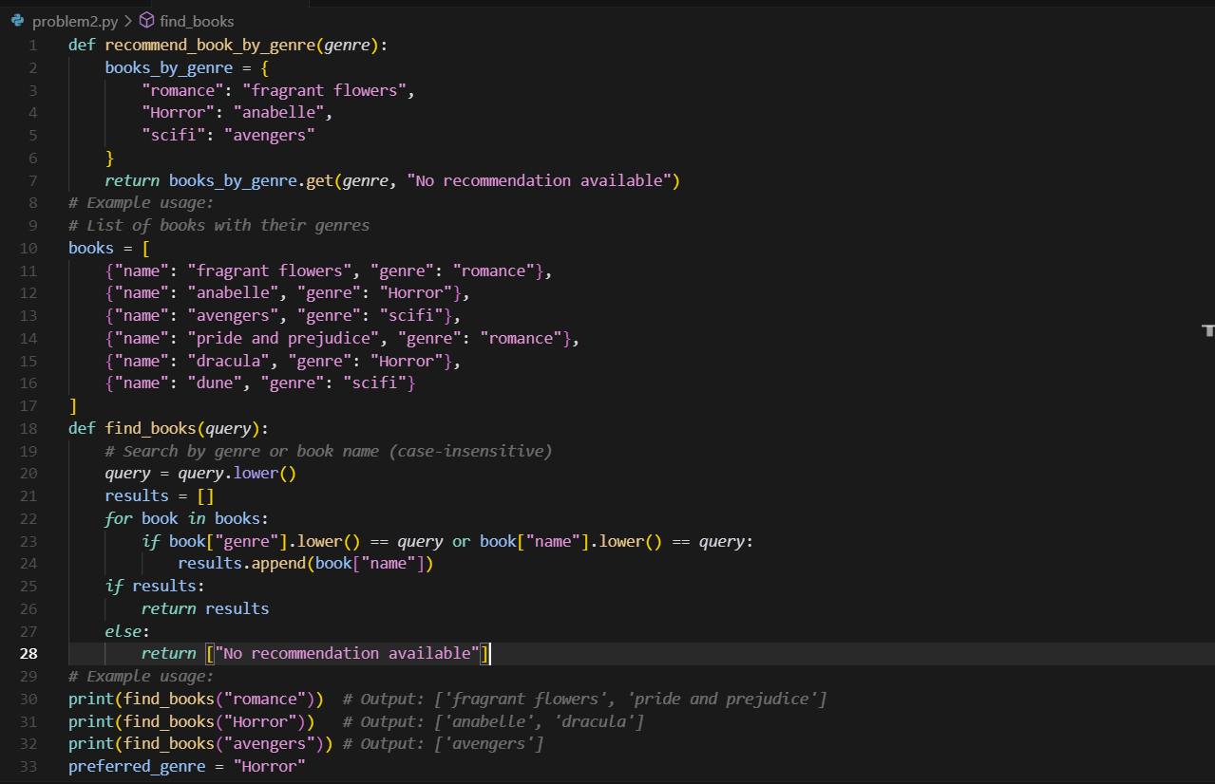

Output:

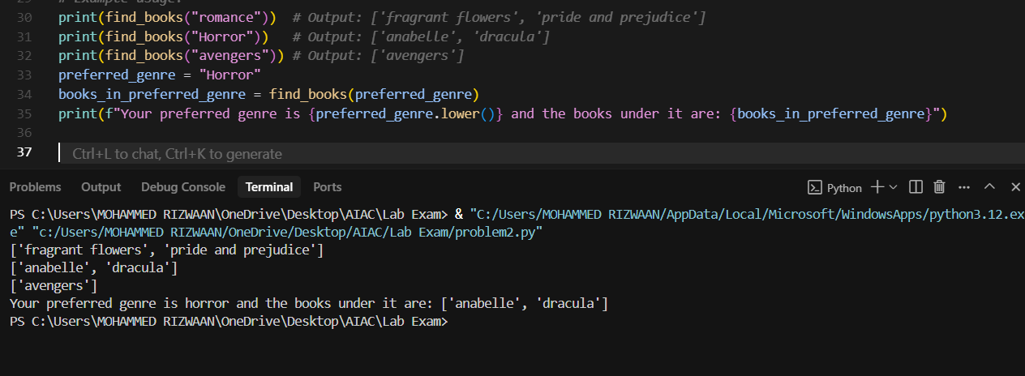

Problem 3:

(2 Marks) Write a Python program that generates all prime numbers between start and end (both inclusive) entered by the user. Use GitHub Copilot along with VS Code. Use few shot prompting

Prompt:

(2 Marks) Write a Python program that generates all prime numbers between start and end (both inclusive) entered by the user. Use GitHub Copilot along with VS Code. Use few shot prompting

Code:

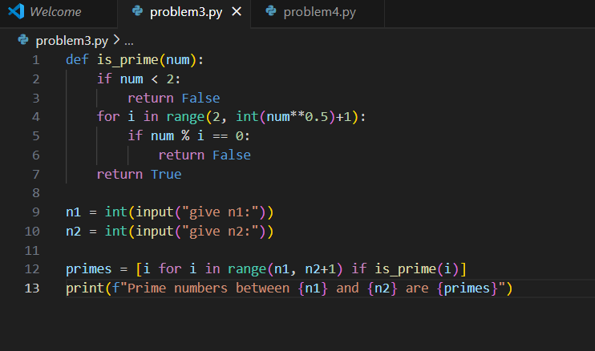

Output

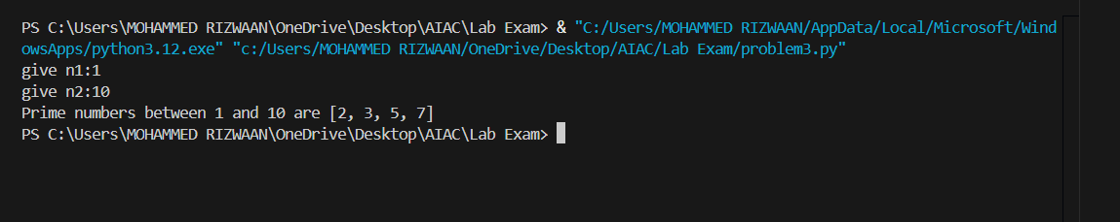

Problem 4:

(2 Marks) Write Python code that takes a list of student names and generates institutional email IDs in the format: @sru.edu.in Example: "Anita Sharma"→ asharma@sru.edu.in. Use GitHub Copilot along with VS Code. Use few shot prompting.

Prompt:

generate a python code which reads a list containing the student names and generates email ids in the format: <firstname><lastname>@sru.edu.in

Example 1:

rizwaan ahmed

output: rizwaanahmed@sru.edu.in

example 2

input:Aniket Varma

output:aniketvarma@sru.edu.in

Code:

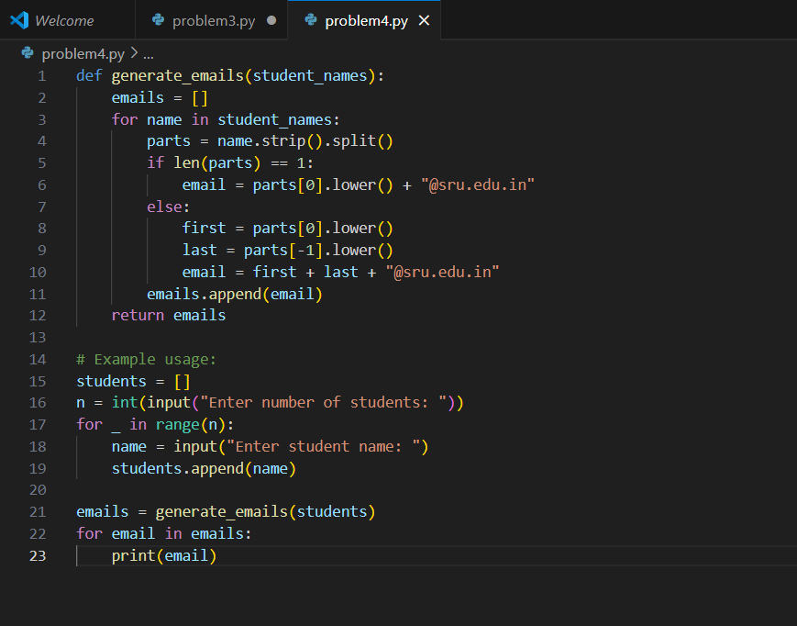

Output:

